**Well Wisher Ads**

Place a Well Wisher ad in the *Ten Minute Play Festival* program to show support for your ACTor--friends and family may place ads too! Feel free to forward this message to others who may wish to place a Well Wisher.

* Well Wishers may be submitted electronically
* DEADLINE: in just 6 day—Wednesday, September 24th

**Sample ad from Alice in Wonderland:**

**Great Job Eddie!**

 We're "mad" about your wonderful performance this summer.

Love from mom, dad, Sarah and Fido the dog

++++++++++++++++++++++++++++++++++++++++++++++++++++

***Instructions for placing Well Wishers Ads***

1. **Name and email address of purchaser:**
2. **Name of ACTor:**
3. **Choose the size of your Well Wisher:**

* Well Wisher (plain text – no graphic/box) up to 15 words: $5
* 1/8 page ad (up to 25 words plus graphic): $15
* 1/4 page ad (up to 40 words plus graphic): $25
* 1/2 page ad (up to 80 words plus graphic): $50

1. **Choose a graphic from the options below and write the word for the choice here:**
2. **Well Wisher Message text:**
3. **Email your Well Wisher order to Nancy Morrison at** [**morrisonblasik@yahoo.com**](mailto:morrisonblasik@yahoo.com)**.**

* Call Nancy at 617-645-2786 if you have any questions.

1. **Pay for Well Wisher:**

* Please make check payable to *Arlington Children’s Theatre* and indicate “Well Wisher” on the memo line
* Give your check to the Rehearsal Assistant, or put in the manila envelope for “Well Wishers” on Matt’s desk

***GRAPHIC OPTIONS***

**The Stain**

[](http://sweetclipart.com/multisite/sweetclipart/files/skunk.png) Skunk

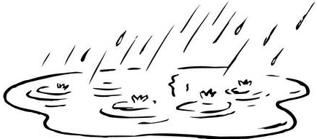 Puddle

**Blow by Blow**

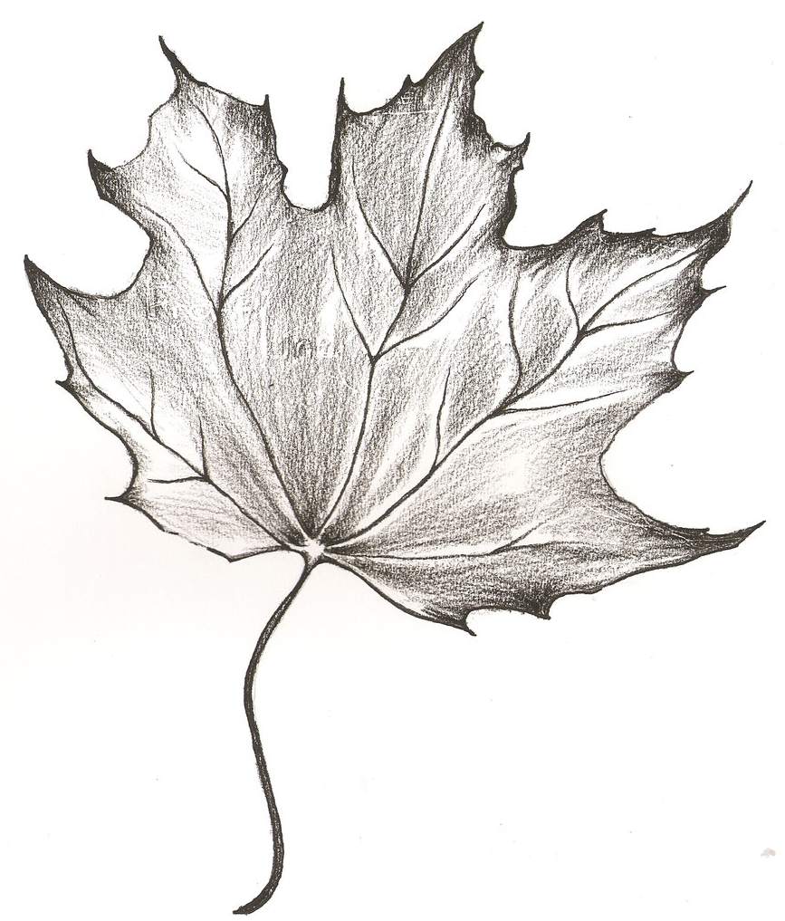 Leaf

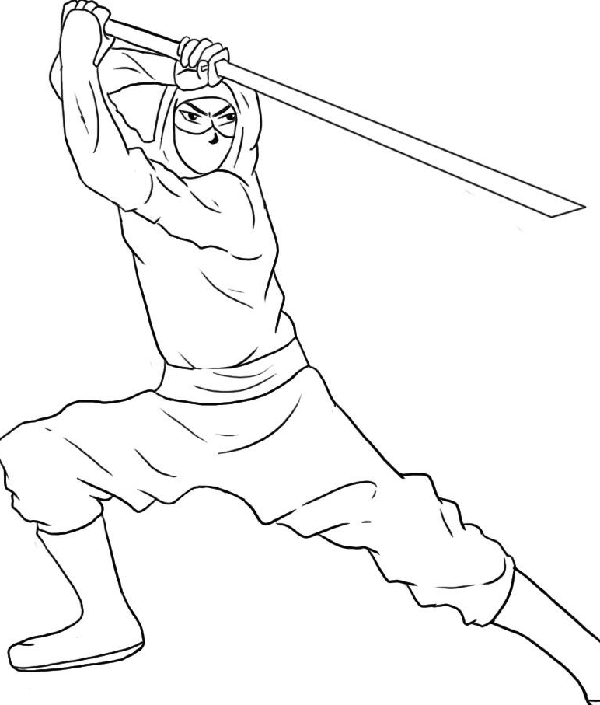 Ninja

 Police

**You Lookin’ at Me?**

 Self-Defense

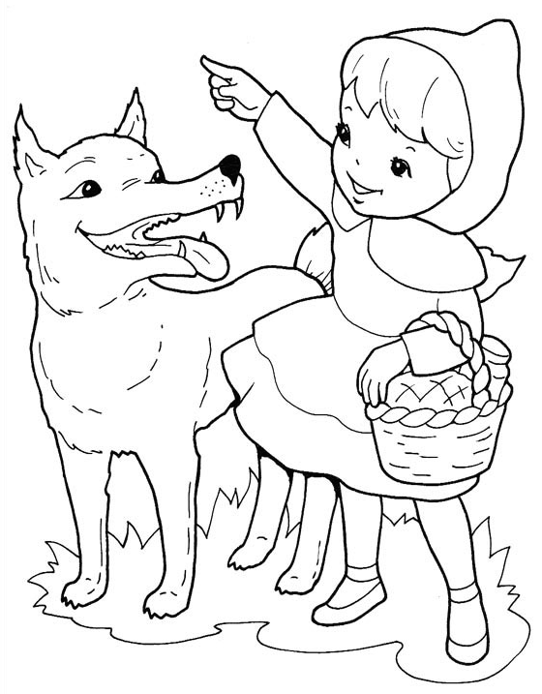 Little Red Riding Hood

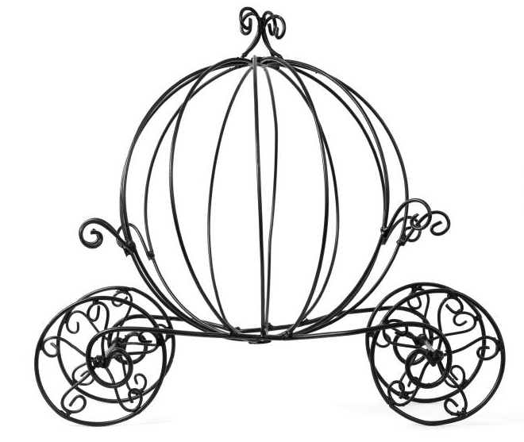 Cinderella’s Carriage

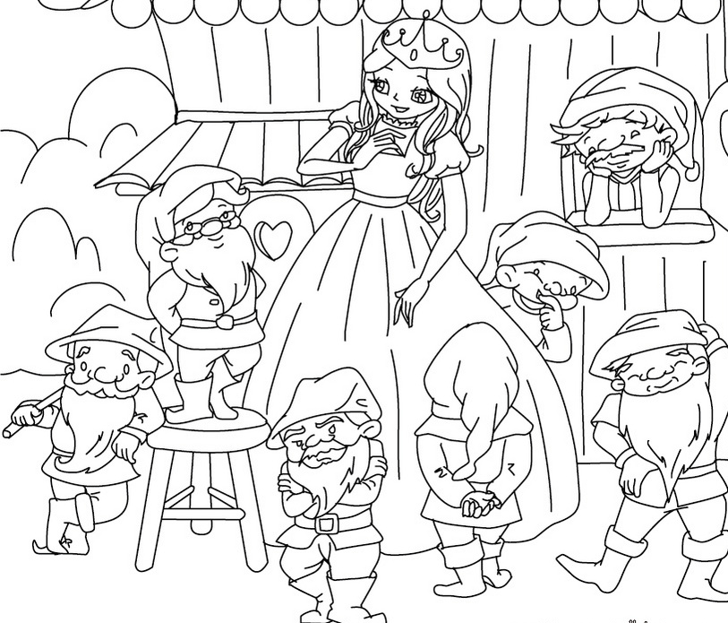 Snow White

**How We Talk in South Boston**

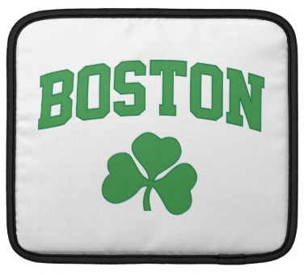 Boston/Southie

 Celtic Shamrock/Southie

**Controlling Interest**

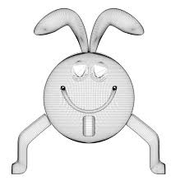 Cootie Bug

 Kickball

 Ant

**The Philadelphia**

 Coffee cup

 Coffee mug

 Universe

**Surprise**

 Heart #1 (love)

 Waitress

**The Spot**

 Heart #2

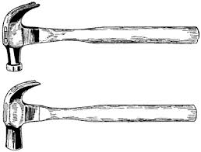 Two Hammers

 One Hammer