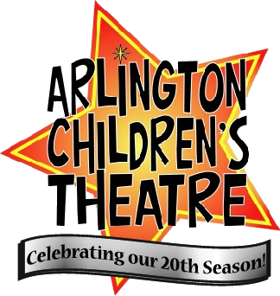
W. Shakespeare Liability Form
(Abridged)

ACTor's Name: ______________ T-Shirt Size: YM YL S M L XL XXL

Responsible party signature:
By signing below, I agree to pay the fee to ACT for my child’s participation and acknowledge the information provided is accurate, and I have read and understand the no-refund policy. Further, I acknowledge receiving the Theatre Etiquette Agreement, understand its importance and agree to abide by its terms.

_____________________________________ ______________________________
Signature of Parent/Guardian Signature of Participant/Child
------------------------------------------------------------------------------------------------------------
Permission and Liability Waiver

I, __________________________________ give permission for _______________ to
Parent/Guardian/Responsible Adult Name Child’s Name
participate in Arlington Children’s Theatre's production of The Complete Works of William Shakespeare (Abridged) and hereby waive Arlington Children’s Theatre and its personnel from liability for any accidental injury and for any damage to or loss of my property. Unless otherwise specified in writing, ACT has my permission to use photographs of my child on its website and in publicity materials for this or other productions or workshops.

_____________________________________ ___________________
Signature of Parent/Guardian Date
------------------------------------------------------------------------------------------------------------
Conflicts Please list any conflicts you have between Mar 24th and May 12th.
PLEASE NOTE THAT THE ENTIRE CAST IS REQUIRED TO ATTEND REHEARSALS AND PERFORMANCES THAT ARE CALLED BETWEEN MAY 12th and MAY 18th.

------------------------------------------------------------------------------------------------------------
OPTIONAL: Permission to Leave Rehearsals by Themselves
Please sign below if you give your child permission to leave rehearsals and/or shows by themselves. By signing below, you absolve ACT of any responsibility once they leave the rehearsal or show space.

_____________________________________ ___________________
Signature of Parent/Guardian Date

