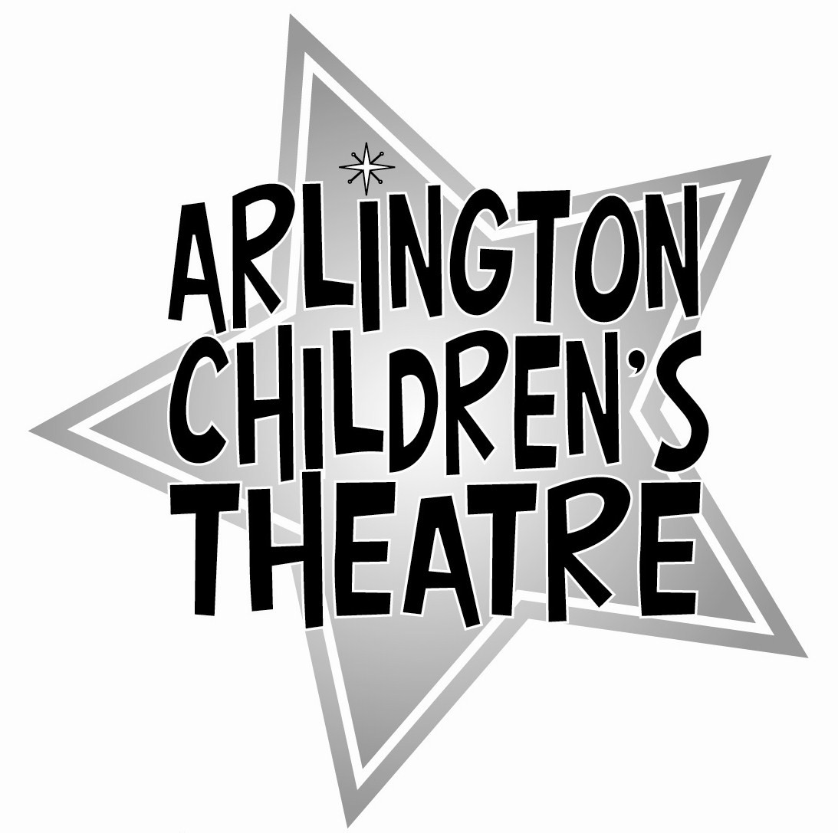

Shrek: The Musical
Biography Information Form

Name: ___________________________________________

Your Role(s) in this show: ____________________________

Age: __________

Hometown: ________________________________________

Previously I have performed in (fine if this is your first show, too!):

My favorite part of being in Shrek has been:

Anything else you’d like everyone to know? Or anyone to thank?

