Arlington Children’s Theatre
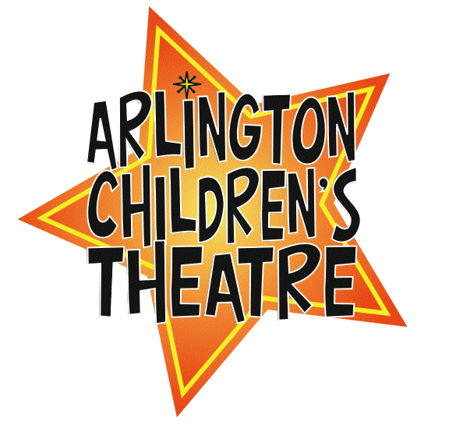
41, Foster Street Unit #5
Arlington, MA 02474

Dear Business Owner,

Arlington Children’s Theatre (ACT) is excited to announce that we are currently producing our annual Ten Minute Play Festival. Children from the towns of Arlington, Cambridge, Lexington, Medford and Watertown are participating in the production. In the past, area businesses have been generous in supporting our productions through advertising their business in the program, and I would like to ask at this time for your support.

If you would like to consider placing an advertisement in the program, please read the attached page carefully and indicate which type of ad you would like to place. We do ask that you provide material as you would like to it to appear.

ACT is a non-profit organization and we rely on support such as yours to sustain our programs. Your support today helps us in our mission to offer affordable theatre for children between the ages of 4-18 in the future, and allows us to provide scholarships to those who need them. All such support is greatly appreciated. Please feel free to visit our website at http://act.arlington.ma.us to find out more.

I would like to thank you in advance for your support of arts programming for our children.

Regards,

Suzanne Leone Lindner
(781) 883-1423
suemarielee@yahoo.com

ACT Business Ad Order Form
Ten Minute Play Festival

Indicate size of ad:

_______$45 Business card - standard size / black & white
_______$80 half page - 4in. (high) x 5in. (wide) / black & white
_______$150 Full page - 8in. (high) x 5in (wide) / black & white
_______$300 inside front cover, inside back cover, back cover / color

Options:
- Create your own ad with the dimensions as indicated (if submitted electronically, pdf format preferred) – enclose your ad as you would like it to appear, sizing can be adjusted if necessary;
- Let us know the specific details of what you would like included in your ad and we will create it for you;
- Enclose your existing business card for business card size ad.

Electronic submissions should be e-mailed to suemarielee@yahoo.com; hard copies should be submitted to ACT, along with your payment. Please make checks payable to “Arlington Children’s Theatre” (please note business name on memo of check), and mail or deliver to ACT. For electronic submissions, please include a copy of your ad with payment.

Address: Arlington Children’s Theatre
41 Foster St., Unit #5
Arlington, MA, 02474

If you would like to discuss other ways to sponsor our shows and programs, please do not hesitate to ask!

This is a short production period - we request that all ads be placed by October 4th, 2013
(special arrangements may be made if a longer period is needed)

Questions?: Contact Suzanne Leone Lindner, 781-883-1423, suemarielee@yahoo.com

