Arlington Children’s Theatre Presents The Sound of Music!

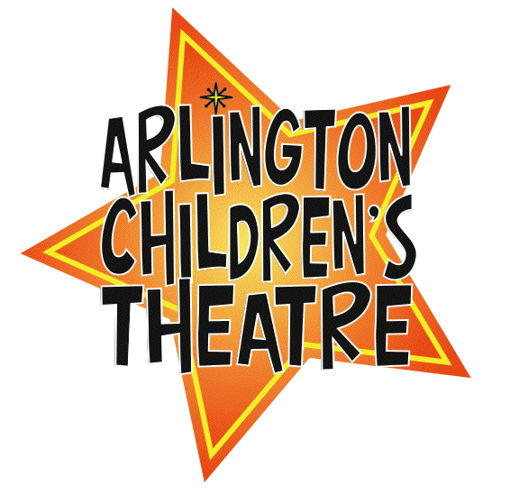
March 14-17, 2013

Support our production of the beloved Rogers and Hammerstein musical

Advertise in our program to reach hundreds of community members!

Yes! I would like to purchase a full page (8in. x 5in.) advertisement for $ 150.

Yes! I would like to purchase a half page (4in. x 5 in.) advertisement for $80

Yes! I would like to purchase a business card size advertisement for $45

Business Name: _____________________________________________ Contact Name: _________________________________ Contact Phone: ______________________________ Contact E-mail: ________________________________________________
Select One:

I would like to create my own ad and email to: soundofmusicproducers@act.arlington.ma.us

I would like ACT to create my ad and I have included
the text for the ad below:

Please make all checks payable to: Arlington Children’s Theatre

ACTors name: ____________________ Amount $______ Cash_____ Check # ______

Receipt for Business Patron - Cut Here

Thank you for supporting Arlington Children’s Theatre!

Business Name ____________________________________________________

Type of ad- Circle One: 1/4 page 1/2 page Full page

Total paid _________ Check one: _______ Cash; ______ Check

