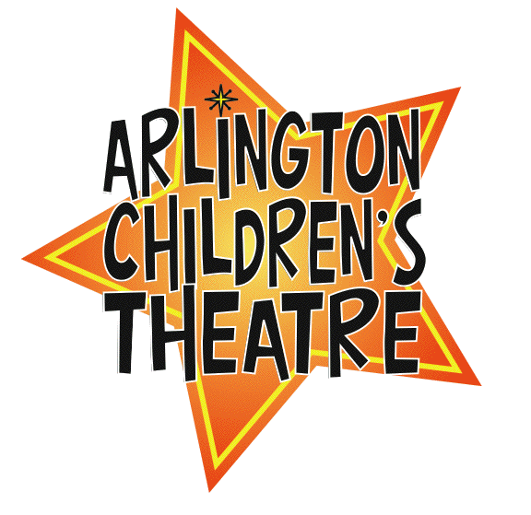

Dear edwina

ACTor’s Bio Form
Show dates: April 26-28, 2013

Please fill out this form and email it to: annsko@gmail.com or bring to rehearsal, by our deadline of April 10th. Thank you!

ACTor’s Name:

Character(s):

Age:

Current Hometown:

Previous Performances (if any):

Your favorite part about being in this show:

Who would you like to thank:

Edwina gives lots of advice from her garage in Paw Paw, Michigan. What is the best advice that you have ever gotten?

