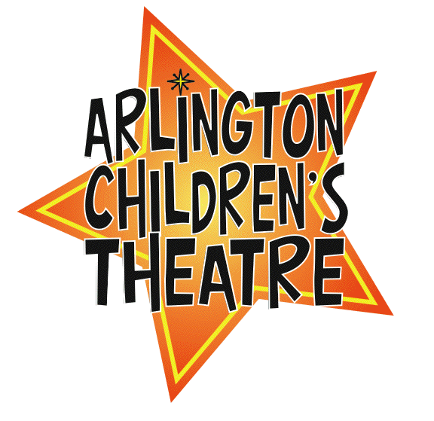

Ten Minute Plays
Bio Form
2012

Please fill out this form and email it to: dianemc4@comcast.net

ACTor’s Name:

Character/Cast:

Age:

Current Hometown:

Previous Performances (if any):

Please write a little bit about each subject or just one or two. Or, feel free to write something on your own. We want to tell the audience a little bit about you. ☺
Reasons you would like to be in the show/your favorite part of being in this show/If you could have any part in any musical/play in the world, what would it be? Anybody you would like to thank?

