Well Wishes for Spring Awakening ACTors!

Want to support your actor for all their hard work? Yes! Why not purchase a cool display ad in the program? Placing an ad is simple; just follow the steps below.

Step 1: Choose the size of Well Wisher that you would like to purchase
Step 2: Choose the graphic you would like (no graphic on Text Only ads).
Step 3: Write your own title (Optional); we will pick a cool font for the title
Step 4: Write down what you want your ad to say. (Please write legibly.)
Step 5: Write a check to ACT for the ad, attach securely to order form and give to a rehearsal assistant, or email the order form directly to Hillary (hillaryd@gmail.com). If you email, please give your check to a producer/rehearsal assistant on site.
Step 6: Submit no later than Friday July 27th – THIS DEADLINE IS FIRM: no ads will be placed after that date.

Example ad with graphics:

Congratulations Kelly on another wonderful performance! Mom, Colin and Beatrice
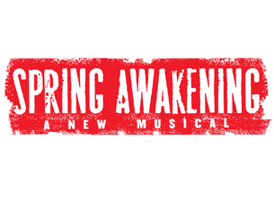

Example of a text-only ad:

We love seeing you sing and dance on stage Marissa! Congratulations to you and the Spring Awakening cast! Love Mom, Dad, Brian and Brynne

Thank you for supporting your ACTor AND ACT!

Your Name:
Cast Member Name:
Select Ad Size:

Text Only: up to 15 words: $5 (no title/graphic/box)
1/8 Page Ad: up to 25 words: $15
1/4 Page Ad: up to 40 words: $25
1/2 Page Ad: up to 80 words: $50

Graphic Choices (will be in black and white in the program):

1.

2.


3.


4.
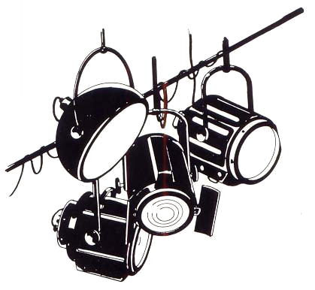

5.


Title: (optional)

What your Ad will say: (Don’t forget to put your cast member's name in your message!)

Payment
Please make your check payable to: ACT and write “ACT Well Wisher” in the subject field of your check. If name on check does not match "Your Name" above, please identify which ad(s) you are paying for. If submitting via e-mail, please give your check to a producer. Please fill out a separate order form for additional ads. You may combine payments into a single check.

