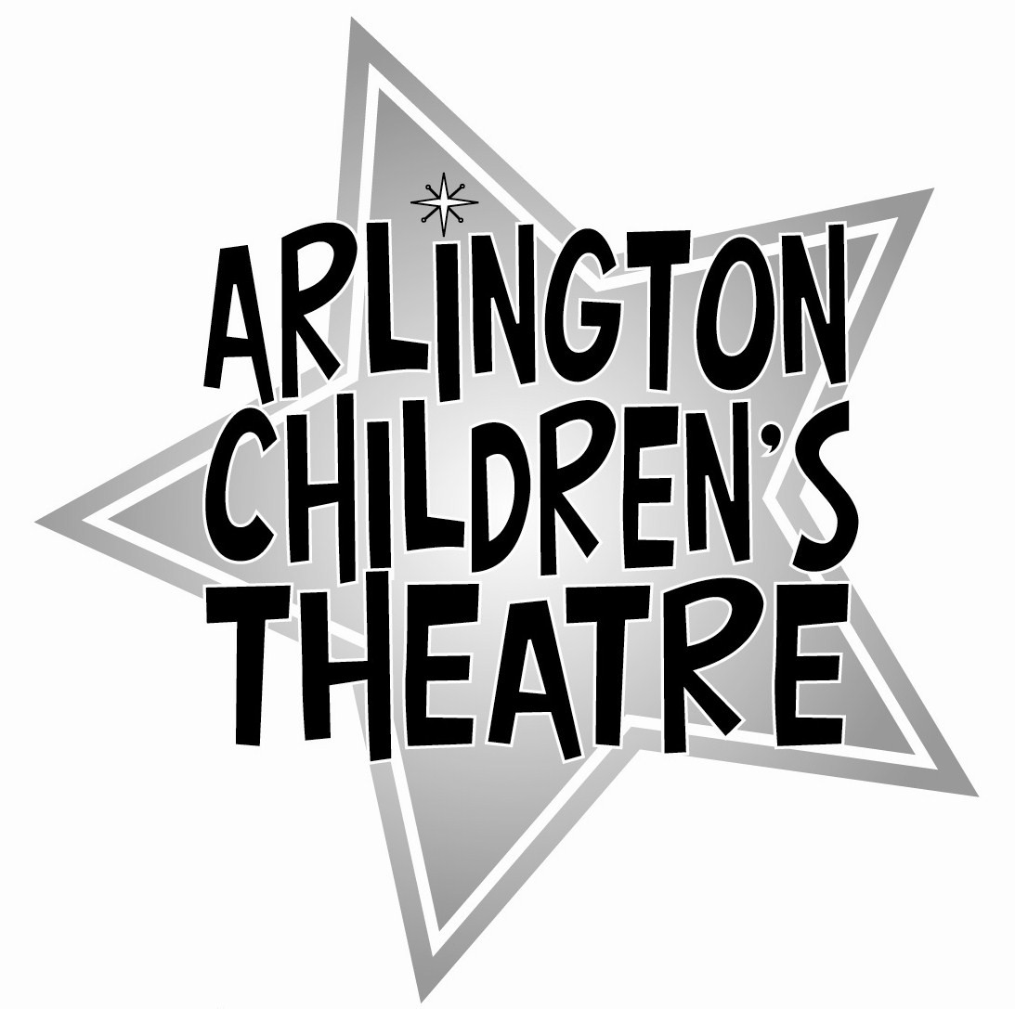
Workshop Liability Form

ACTor's Name: _____________________________

Workshop Name: _____________________________

Health Information
Does the participant have any special needs (e.g., medications, illnesses, allergies) that ACT should be aware of?

________________________________________________________________________
------------------------------------------------------------------------------------------------------------
Responsible party signature:
By signing below, I agree to pay the fee to ACT for my child’s participation and acknowledge the information provided is accurate.

_____________________________________
Signature of Parent/Guardian
------------------------------------------------------------------------------------------------------------
Permission and Liability Waiver

I, __________________________________ give permission for _______________ to
Parent/Guardian/Responsible Adult Name Child’s Name
participate in the Arlington Children’s Theatre workshop named above and hereby waive Arlington Children’s Theatre and its personnel from liability for any accidental injury and for any damage to or loss of my property. Unless otherwise specified in writing, ACT has my permission to use photographs of my child on its website and in publicity materials for this or other productions or workshops.

_____________________________________ ___________________
Signature of Parent/Guardian Date
------------------------------------------------------------------------------------------------------------
OPTIONAL: Permission to Leave Workshop by Themselves
Please sign below if you give your child permission to leave the workshop without a parent. By signing below, you absolve ACT of any responsibility once they leave the workshop space.

_____________________________________ ___________________
Signature of Parent/Guardian Date

