Arlington Children’s Theatre Participation Policy
Behavior Standards and Theater Etiquette

Welcome to the Arlington Children’s Theatre family. As with any successful family we have standards of behavior that ensure that every participant will enjoy a safe and productive experience. Every participant will be expected to know the rules and behave in a manner that will continue to make the ACT experience so special.

Respect, Preparation, and Safety.
Understanding these three key concepts is a mandatory requirement.

RESPECT all people you come in contact with at ACT. This starts with respect for yourself and your fellow actors, and extends to everyone who is involved with a production. Good behavior is not something we turn on and off when we feel like it. ACT is a well-respected organization in our community, and each participant’s behavior reflects on our organization, even when we are outside the theatre—or interacting via social media online. Actions will always be to enrich the ACT experience and never detract from it. The positive experience that we all feel working together is something that needs to be nurtured and protected.
PREPARATION is essential to our success. Lateness, unexcused absences, and failure to learn lines all harm the theatre experience of others. We require all participants to be prepared for all rehearsals, to communicate with producers in advance of absences (e-mail), and to be aware of their schedule. Be on time for every event and be clean and appropriately dressed.
SAFETY is a promise we make to each other and our families. We are concerned that all participants act in a manner that protects the safety of all, and ACT staff or board members will be notified if any safety issue is found. Acting and behaving in a safe manner is another way we show our respect for each other.

Theater Etiquette
This can be simply defined as always doing the right thing.
- All financial arrangements must be made prior to casting: all families should familiarize themselves with our refund policy at this time
- Always turn in the proper forms filled out correctly, and on time.
- Honor the schedule: let conflicts be known in advance, make all rehearsals, arrive on time and prepared.
- Memorize all your lines, help others learn theirs, and respect others by doing something productive in down times. The theater is the actor’s temple; treat it as such.
- Respect the property of others, clean up after yourself—and others—and leave any space cleaner than you found it!
- Make the drop off and pick-up of the children seamless. Parents and children: communicate changes in schedules and pick-up times. Parents: let producers know if your child needs special accommodations of any kind. Children should not be released without an adult unless producers know.

Please sign the next page if you have read and understand our Participation Policy.

We believe in our organization, and in you. Show your respect and pride in ACT by always acting responsibly; make your family and us proud!

Failure to comply with our policies will result in disciplinary action following two documented warnings, which may include dismissal. Dismissal from a production or workshop may impact future casting decisions.

We the undersigned have read and understand the Arlington Children’s Theatre Participation Policy. We agree to abide by the policy as it is written.

Participant’s Signature ________________________________________________
Date _______________________________________________________________

Parent or Guardian’s Signature _________________________________________
Date ______________________________________________________________

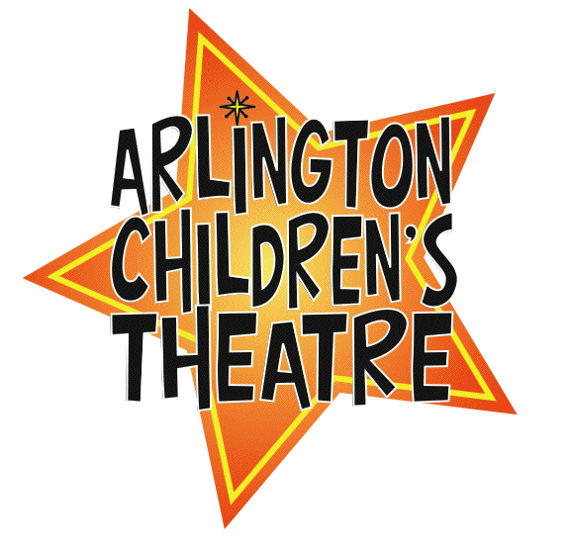

Revised by JDaley April 2010

