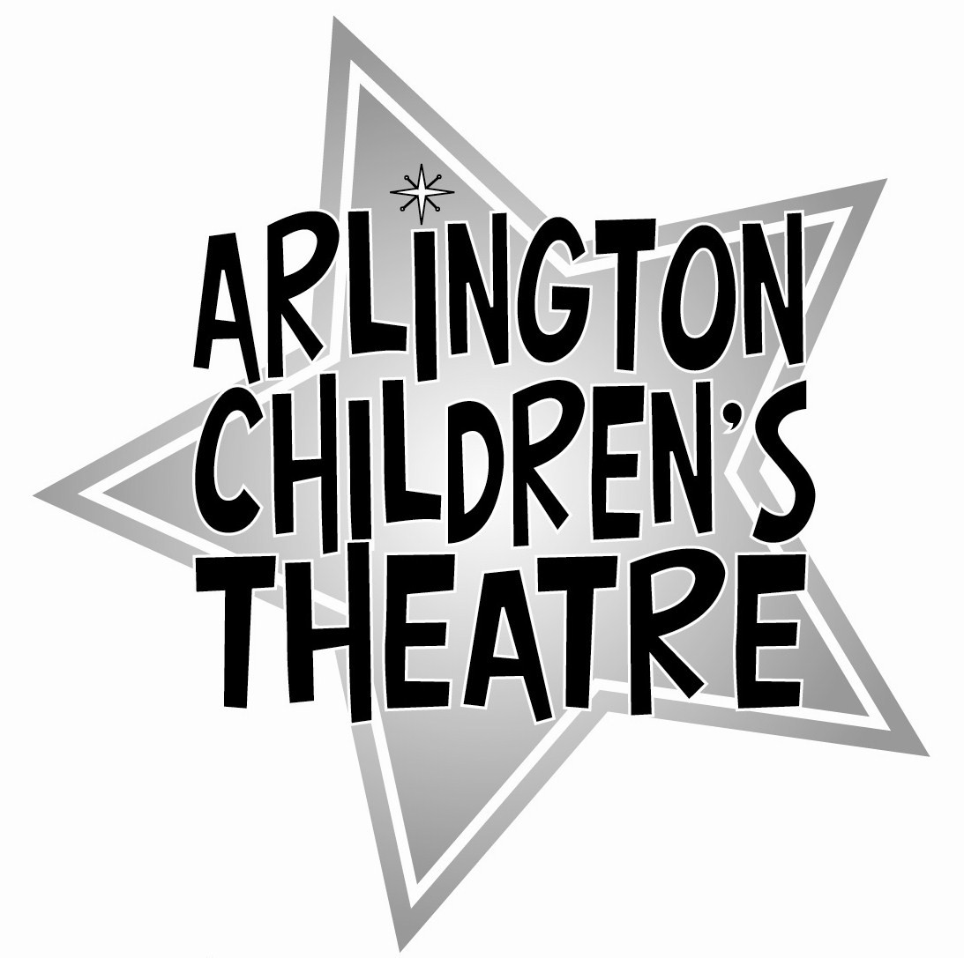

Theatre Etiquette Agreement

The following Theatre Etiquette guidelines will ensure that all rehearsals run smoothly. Please read this carefully and retain this agreement future reference.
- All forms must be completed at your audition. This includes the audition form, the liability form, the medical consent form and the form indicating your acceptance of this agreement.

- All fees must be paid, or scholarship arrangements made, by the first rehearsal.
- Cast members are expected to attend all rehearsals that are scheduled for their character(s).
- The general schedule is presented at audition time and all conflicts must be listed thoroughly on the audition form. This production involves a great number of people, and future conflicts, except for emergencies, may not be accommodated.

- A full rehearsal and performance schedule will be given out at the first rehearsal. Every effort will be made to follow the rehearsal and performance schedule as presented to you. However, emergencies do arise and adjustments may need to occur because of them.

- No absences are allowed, with the exception of emergencies and those absences approved by the Producer at the start of the production. Your role may be re-cast if you are absent without notice. If an emergency does occur, call the Producer immediately.

- Whatever his or her schedule, each actor needs to be available to attend all Tech Week rehearsals and Performances in which they are scheduled to perform.

- Cast members are expected to arrive at all rehearsals and performance calls on time. Tardiness causes delays and is unfair to others. If you arrive early, please enter and wait quietly.

- When committing to a role, cast members should understand that they will need to memorize all of their lines, and learn all songs and dances. They should make time at home to do this. Parents/adults should be willing to help them with this important task.

- All rehearsal spaces have been generously donated for our use. You are expected to treat these places with respect and keep them clean.

- To keep busy in the event that you have a bit of free time during rehearsals, please be prepared with some quiet activity that does not disrupt the ongoing rehearsal or your fellow ACTors. Valuable items should be left at home.

- An adult must know where you are at all times. Please do not leave without telling one of the staff.

- When dropping off children for rehearsal, parents or responsible adults are asked to come inside the building to confirm dismissal time and to pick up any announcements.

- At dismissal time, parents or responsible adults are asked to come to the entrance of the rehearsal space to pick-up their child(ren). ACT maintains a list for each production of those participants who are allowed to leave on their own – please notify the Producer at the start of the production if your child will be arriving and/or departing from rehearsal unaccompanied by an adult.

Participation Policy and Behavioral Standards

We are thrilled to have your family participate in Arlington Children’s Theatre productions and workshops. Our policy has always been to provide a fun, safe, inclusive and supportive environment for children and families to enjoy the challenges and delight of live theatre. In order to provide this environment to all of the children and families involved, we have established the Theatre Etiquette policy, and have supplemented it with this agreement about expectations for behavior. Any participant that behaves in a manner that is inconsistent with these expectations will be spoken to immediately by a parent volunteer, producer or director. If no change of behavior is evident, the participant’s parent or responsible adult will be notified. If necessary, the ACTor will be asked to not participate in the production or workshop.

Please read through this Participation Policy and Behavioral Standards thoroughly and sign where indicated below.

RESPECT FOR EACH OTHER– Our acting community depends on mutual respect. Child participants, or ACTors, need to respect the authority of the directors, choreographers, musical directors, workshop coordinators, teachers, parent volunteers and other ACTors. Defiance, verbal abuse, foul language, or any disrespect has no place in our organization. Bad attitudes, gossip, mocking and other forms of disrespect have no place in our organization.

RESPECT FOR OUR SPACE– Arlington Children’s Theatre rents space that is made available to us by generous churches, libraries and other relatively affordable landlords. All of the ACTors need to respect their physical surroundings, keep the spaces clean, and help out when asked by the adults in charge of the productions and workshops. Graffiti, litter, and general mess will not be tolerated. Any ACTor defacing any property related to any ACT production, workshop, party or any other event will be held responsible, along with their parent or responsible adult.

FOLLOWING DIRECTION – The artistic directors of our productions and workshops need full participation and attention from every ACTor. Rehearsal time is limited and needs to be used efficiently, with the ACTors participating fully. The artistic staff expect the ACTors to study their lines, learn their songs, and know their dance steps. ACTors who cannot follow direction will be spoken to, and their parent will be notified in the event that this behavior is compromising the program as a whole.

BEING PREPARED – Being on time, dressed appropriately, and ready for rehearsal benefits the whole team. ACTors are expected to notify the Producer in advance in the event of absences. ACTors are expected to have access to the schedule of rehearsals and a means of knowing of any changes. Most communication for large productions is done by email. Any family without access to email should notify the Producer, and an ‘email buddy’ will be assigned to share all communications in a timely manner.

SAFETY – ACT strives to provide a safe environment for all participants. All rehearsals and performances are monitored by responsible adult volunteers. Each participant is expected to behave in a safe and responsible manner that demonstrates respect for themselves and respect for others. Any activity that is deemed unsafe or potentially hazardous will be reported to the Producer or workshop coordinator. Serious or repetitive unsafe activity will result in the dismissal of the participant from the workshop or production. Possession of any hazardous item will result in immediate dismissal of the participant and notification of their parent or guardian.

SPECIAL NEEDS OR CONCERNS – Arlington Children’s Theatre is an inclusive organization, with children of many ages and backgrounds. Parents need to notify ACT of any special needs and concerns, particularly related to learning issues, behavioral issues, medication, and allergies, so that all of the ACTors involved in any production or workshop can be made to feel at home, and all of the ACTors can be safe and protected. If for any reason, ACT Producers, directors or Board members believe that participation with ACT is not in the best interest of the child or the production as a whole, the parent or responsible adult will be consulted. In some instances, a parent or responsible adult may be asked to accompany their child to rehearsals and shows.

ACT reserves the right to limit the involvement of any participant who cannot reasonably comply with these behavioral standards.

Please sign below and return this page (only) to the Producer at the time of your audition or first workshop meeting. Keep your copy of the Theatre Etiquette Agreement and the Participation Policy and Behavioral Standards for future reference.
Thank you in advance for your cooperation!

We have read both the Theatre Etiquette Agreement and the Participation Policy and Behavioral Standards as presented by Arlington Children’s Theatre. We understand the need for these guidelines and agree to abide by them for the duration of this workshop / production.

___________________________________________________________________
Participant’s Signature / Date

___________________________________________________________________
Parent/Guardian’s Signature / Date

