Arlington Children’s Theatre
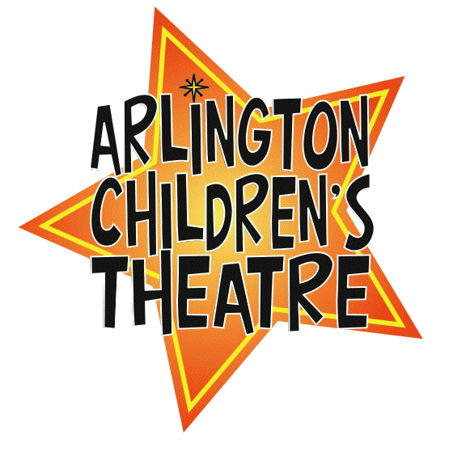
41, Foster Street Unit #5
Arlington, MA 02474

Dear Business Owner,

Arlington Children’s Theatre (http://act.arlington.ma.us/) is excited to announce that it is currently working on a production of <ADD NAME OF SHOW>. We have children from Arlington and 19 other neighboring communities participating in our productions.

In the past, Massachusetts businesses have been generous in supporting our productions through advertising their business in the program, and I would like to ask at this time for your support.

If you would like to consider placing an advertisement in the program, please read the attached page carefully and indicate which type of ad you would like to place.
We do ask that you provide material as you would like to it to appear.

ACT is a non-profit organization and we rely on support such as yours to sustain us so
we greatly appreciate all contributions. Your support today helps us in our mission to offer affordable theatre for children between the ages of 4-18 in the future, and allows us to provide scholarships to those who need them in order to be part of our program.

I would like to thank you in advance for your support of arts programming for our children.

Regards,

<YOUR NAME AND CONTACT INFO>

Please circle below your choice for placing an ad and include any details you may want to add, such as “Good Luck Cast”

$45 Business card: standard size

____________________________________________

$80 half page 4in.x 5in.

____________________________________________

$150 Full page: 8in. x 5in

_____________________________________________

If you would like to consider purchasing the inside cover or back page for $300, or you would like to discuss other ways to sponsor the shows please do not hesitate to ask!

Please enclose any specific materials, as you would like them to appear.
The sizing can be adjusted if necessary.

All ads should be placed by <DATE TWO WEEKS BEFORE THE FIRST PERFORMANCE>.

Checks can be made payable to:
Arlington Children’s Theatre.

