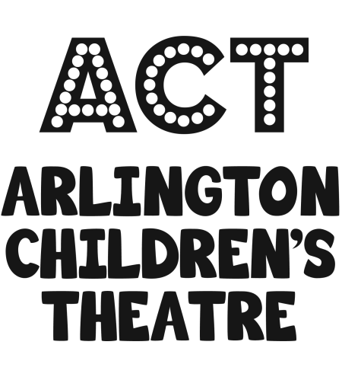

The following is a parental consent permit from the Arlington Children’s Theatre regarding care and treatment of my child in the case of a medical emergency during his/her participation in the following program:

Name of Workshop / Show: _________________________________________________________

Parental Consent for Medical Treatment

The law requires that parental permission be obtained for medical procedures on minors. In the event of a medical emergency, I hereby give permission to the Arlington Children’s Theatre to secure medical treatment, including hospitalization, for the person named below. I also give permission to the Arlington Children’s Theatre to arrange necessary related transportation for my child.

Child’s Name: ___________________________________________ Date: ____________

Parent/Guardian’s Name _____________________________________________________

Parent/Guardian’s Phone # _____________________ Alternate Phone #_____________________

Parent/Guardian’s Signature:_______________________________________________________

Alternate Contact if Parent/Guardian cannot be reached:

Contact’s Name _____________________________________Relationship to Child ______________

Contact’s Phone # _____________________ Contact’s Alternate Phone # _____________________

Child’s doctor’s name ____________________________ Doctor’s Phone #__________________

Is your child covered by health insurance for doctors and hospital bills? _______________

If “yes” what company? _____________________________________________________

Policy # _________________________________________________________________

Policy Holder Name: _______________________________________________________

. . . . . .

Does your child have any allergies? Yes ____ No ____

If yes, please list: __________________________________________________________

Does your child require the use of an Epi-Pen? Yes ____ No ____
If yes, you must leave a prescribed Epi-Pen with the program director while your child attends the program.

**Please note: Staff will not be able to administer medicine to children except in the event of a life threatening allergic reaction requiring the use of an Epi-Pen. Children needing to take medicine during the day must be able to self-administer. If a child must take medication during the program day, the medication (in its original package) and dosing information must be left with the program staff at the start of the day. Self-administration of any medication must be done in the presence of a staff member.

Arlington Children’s Theatre
115 Massachusetts Ave.
Arlington, MA 02474
Medical Policies and Procedures

1. The program director, producer, or designated ACT Board member, will obtain a basic first aid kit which will be in a predetermined location for the duration of the program. The first aid kit will be inventoried and restocked as needed at the end of each day.

2. Any illness or injury, not requiring emergency treatment (i.e. vomiting, sprains, suspected fever, etc.), will be referred to the parent or guardian for further evaluation and medical intervention.

3. In the event that the child has a known allergy that requires the use of a prescribed Epi-Pen, the program director, producer, or designated ACT Board member will be instructed on administering the Epi-pen for use during an anaphylactic allergic reaction.

Health Guidelines:

Children should not be sent to an ACT program or rehearsal with any communicable illness, e.g. strep throat, conjunctivitis, fever above 100 degrees. If any of the above are suspected, parents will be notified and child will be asked to go home.

Emergency Procedures:

In the case of a life threatening medical emergency, 911 will be called.

The program director, producer, designated ACT Board member will notify parents by telephone of any emergency requiring more than minor first aid. If the parent or alternate contact person cannot be reached, ACT will acquire emergency medical treatment as described in the Parental Consent for Medical Treatment form.

