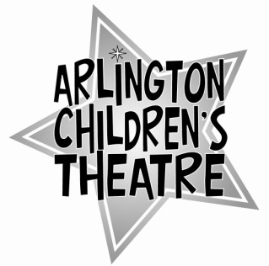
For those ACTors who wish to learn something about theatre production or direction, ACT offers students the opportunity to intern with the theatre professionals we hire to create our shows. This opportunity is available to experienced ACTors, those who’ve shown the ability to be responsible, who work well with children, and who are able to lead effectively. Although ACT interns will not be paid, they are sometimes asked to have an on-stage role in the show they intern for.

Please fill out the application below:

Name _______________ Age: ____ Grade: _____ Phone: _____________________

1. Briefly list your theatre experience, including shows with ACT:

2. List any special skills related to theatre that we should be aware of (e.g., lighting experience, dance, gymnastics, voice or choral work, etc.):

3. Do you have any experience working with or leading groups of children? Please specify.

4. References: please list at least two adults (with their phone numbers) who we can speak to about your ability to perform responsibly as an intern:

5. Why do you want to intern with ACT?

6. Please attach one written recommendation from an adult (this may be written by one of the two adults listed in #4).

