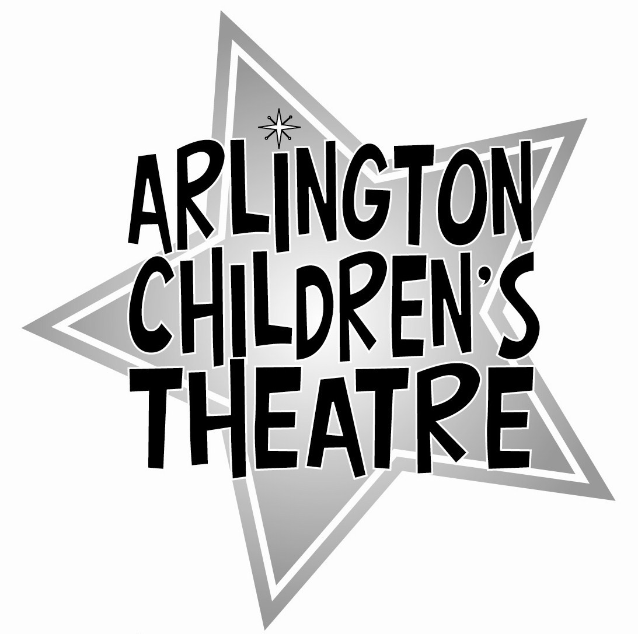
(Name of Show)
Order Form
Due no later than (deadline)

Name of ACTor: __________________________________ Blue Cast Red Cast (circle one)

______________________________________________________________________________
WELL-WISHER ADS
Place an ad of 15 words or less for $5 or purchase a large display ad in the program to wish your ACTor good luck. Select the type of ad and write your message on the attached form, and put the total price here:
Total for all program ads: $ ____
______________________________________________________________________________

FLOWERS
Purchase a bouquet of flowers for your ACTor for $8 – save a trip to the florist!
# of bouquets: _____ x $8 = $______
Flowers to be picked up on (show date / time)____________
(show date / time)____________
(show date / time)____________
(show date / time)____________
NOTE: You must pick up your flowers at the theatre on the specified date and deliver them to your ACTor.
___________________________________________________________________

ANNUAL FUND 2008/2009
Please help support ACT and help us provide low-cost, accessible theatre for children of all ages and backgrounds by becoming contributing to our Annual Fund. Categories are:
ACTor: $50 Stage Manager: $100 Director: $250 Producer: $500 Executive Producer: $1000
_________________________________________________________________________________________________

TOTALS

Program Ads $_________

Flowers $_________

Annual Fund $_________

GRAND TOTAL $__________

Make checks payable to ACT &
give to producer at next rehearsal. For ACT use:
Cash:
Check:
Name on check:
Check #:

