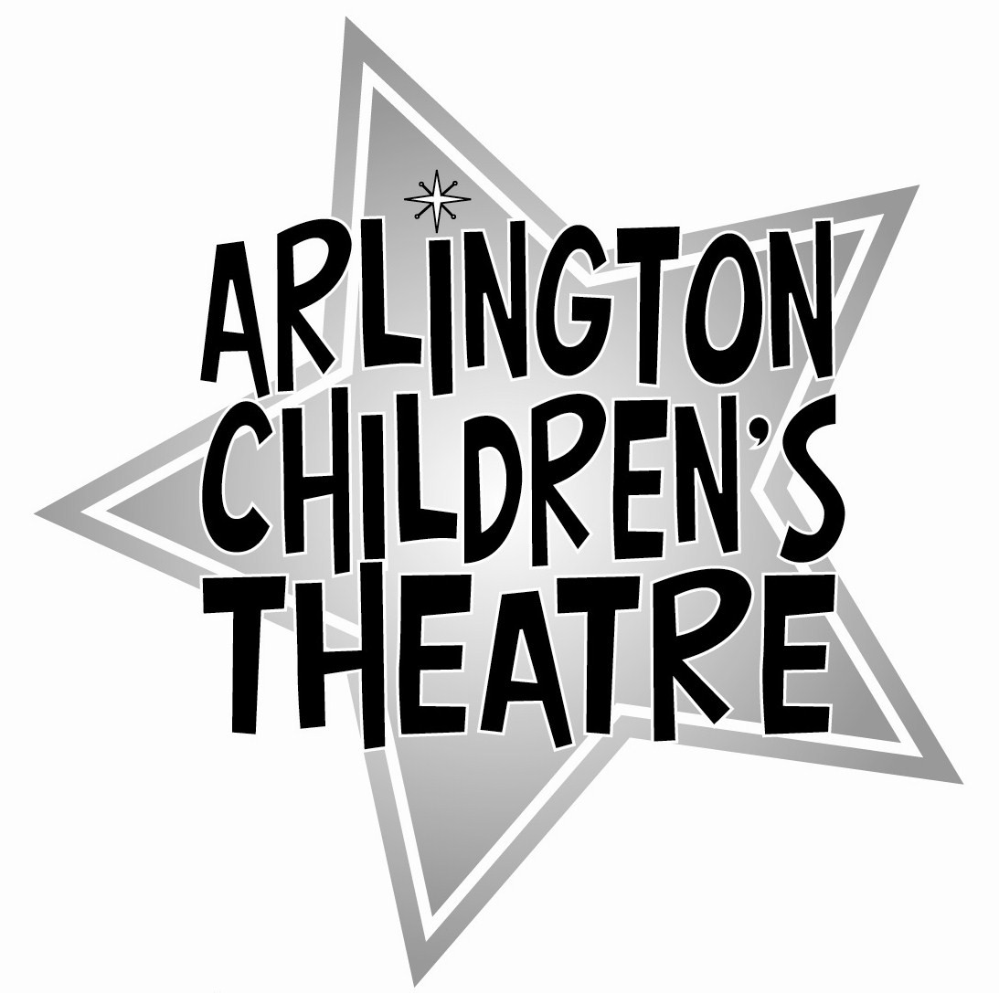

(name of show)
Additional T-shirt Order Form

Each cast member will receive a (name of show) t-shirt (included in the registration fee). Cast member shirt sizes have been collected during the audition process. Use this form if you would like to order any additional shirts for family and friends.
ALL orders must be received by (deadline for orders).

Cast Member’s Name(s): ____________________________________________

Cast (circle one) Red Blue

Please specify shirt size and number:

T-shirt size | Number of shirts
Youth Medium
Youth Large
Adult Small
Adult Medium
Adult Large
Adult XL
Adult XXL

Total T-Shirts Ordered __________ x $15.00 = ______________

Please make checks payable to ACT.

Questions? Contact Gretchen LaPan at gdlapan@act.arlington.ma.us

Order received by / date_______________________________

Cash / Check #_________________ Amount $__________

