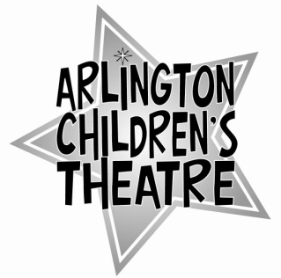
For those ACTors who wish to learn something about theatre production, ACT offers students the opportunity to direct a show, with the guidance of our staff and Board. This opportunity is available to experienced ACTors, those who’ve shown the ability to be responsible, who work well with children, and who are able to lead effectively.

Please fill out the application below:

Name _______________ Age: ____ Grade: _____ Phone: _____________________

Email Address: ___________________________________

1. Briefly list your theatre experience, including shows with ACT:

2. List any special skills related to theatre that we should be aware of (e.g., lighting experience, dance, gymnastics, voice or choral work, etc.):

3. Do you have any experience working with or leading groups of children? Please specify.

5. Why do you want to direct with ACT?

6. Have you taken a directing workshop with ACT or worked as a Stage Manager, etc?

4. References: please list at least two adults (with their phone numbers) who we can speak to about your ability to perform responsibly as an intern:

5. Please attach one written recommendation from an adult (this may be written by one of the two adults listed above).

