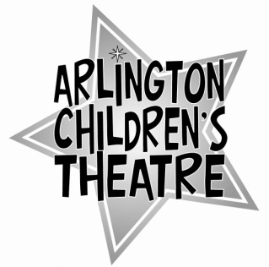
ACT offers ACTors the opportunity to learn something about theatre production with the guidance of our staff and Board. This opportunity is available to experienced ACTors, those who’ve shown the ability to be responsible, who work well with children, and who are able to lead effectively.

Please fill out the application below:

Name _______________ Age: ____ Grade: _____ Phone: _____________________

Email Address: ___________________________________

I am applying to be:
□ Director □ Stage Manager □ Junior Counselor

1. Briefly list your theatre experience, including shows with ACT:

2. List any special skills related to theatre that we should be aware of (e.g., lighting experience, dance, gymnastics, voice or choral work, etc.):

3. Do you have any experience working with or leading groups of children? Please specify.

4. Why do you want to be a Counselor for ACT's summer day program? What strengths do you think that you could bring to the program?

5. References: please list at least two adults (with their phone numbers) who we can speak to about your ability to perform responsibly as an intern:

6. Please attach one written recommendation from an adult (this may be written by one of the two adults listed above).

7. ACT's summer day program will run from June 16th – August 18th. This year, we are interested in hiring counselors to work for more than one two-week session. With that in mind, please list your availability during all 4 sessions, and indicate whether or not you would be interested in working multiple sessions.

